The Ohio State University
Freshman Seminar Program
Course Proposal

Course Information.

- Attach a sample syllabus that includes the following. (Sample syllabi can be found at http://freshmanseminars.osu.edu).
  - the course goals
  - a brief description of the content
  - the distribution of meeting times
  - a weekly topical outline
  - a listing of assignments
  - grade assessment information (A-E or S / U)
  - required textbooks and / or reading list
  - the academic misconduct and disability services statements (sample statements can be found at http://artsandsciences.osu.edu/currofc/resources.cfm)

- Attach a brief biographical paragraph that includes the current research interests, teaching awards and honors, and undergraduate courses taught by the participating instructor(s). The paragraph will be included in materials for first-year students.

Chrsitiane Buuck, Department of English, College of Arts and Sciences
Proposer’s Name and Academic Unit

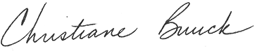
Proposer’s Signature

Buuck.3@osu.edu 614-563-0482
Proposer’s e-Mail Address Contact Phone Number

10-6-16
Submission Date
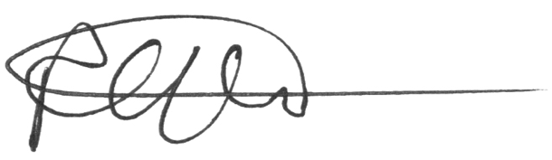 October 5, 2016
_________________________________________________________________________________________________________
Signature Department Chair of Academic Unit

Please indicate the semester you would like to offer the seminar: AU’_______ SP’___17___

This form and any attachments should be mailed to Freshman Seminar Program, 100 Denney Hall, 164 Annie and John Glenn Avenue, ATTN: Dawn Nolen or e-mailed to nolen.2@osu.edu. For additional information, please call 614/292-4680.

Rev. 3/10/16

